Why Does Every Transformer Need a Switchboard?
In power systems, switchboards are essential companions to transformers, providing a crucial layer of control and protection to ensure safe and reliable power distribution. More than just power distribution hubs, switchboards act as the first line of defense in any electrical system. Here’s why pairing a switchboard with a transformer is so important:

⚡1. Overload and Short Circuit Protection
Equipped with circuit breakers and fuses, switchboards automatically disconnect power when electrical loads exceed safe limits, protecting both equipment and personnel from potential hazards.

2. Efficient Power Distribution
After transformers convert the voltage, switchboards distribute electricity to various circuits and equipment, ensuring that each endpoint receives stable, appropriate voltage. This setup maximizes energy efficiency and reduces unnecessary power loss.

3. Monitoring and Control Capabilities
Modern switchboards often come with intelligent monitoring systems that track parameters like current and voltage in real time, allowing potential issues to be identified early. Programmable switches also allow remote control and management, perfect for smart grids and energy-saving applications.

4. Ease of Maintenance and Repairs
With a modular design, switchboards make maintenance and repairs straightforward. Technicians can easily replace modules or upgrade components as needed, reducing downtime and maintenance costs significantly.

5. Safety and Compliance
Built to meet national and international safety standards, switchboards are designed with high protection levels to isolate circuits, prevent accidental contact with live parts, and enhance overall user safety.

In Summary
Switchboards are the backbone of any reliable power system, providing the control, protection, and distribution needed for seamless operation. For transformer operators, choosing a high-quality switchboard is essential to boosting power system reliability and minimizing maintenance costs. Regular inspections and proper maintenance are key to keeping the entire system running smoothly and safely!
Have questions about switchboards and transformer integration? Reach out to our team anytime! #Switchboard #Transformer #PowerSystems #Safety #EnergyEfficiency #JZP #JIEZOUPOWER
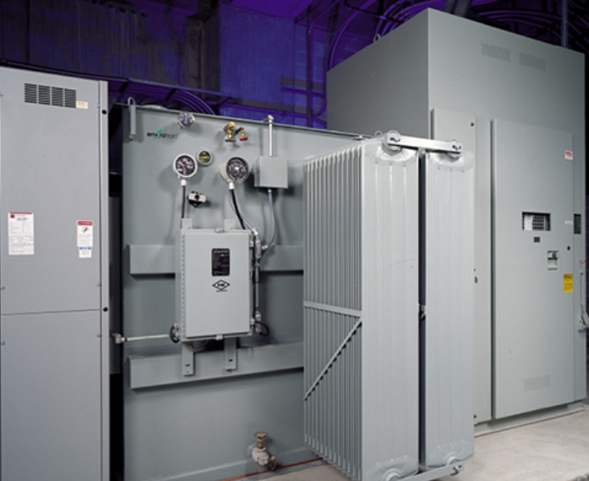

**为什么每台变压器都需要配电柜？**
在电力系统中，配电柜是变压器的重要伙伴，提供关键的控制和保护层，以确保安全可靠的电力分配。配电柜不仅仅是电力分配中心，更是任何电气系统的第一道防线。以下是配电柜与变压器搭配如此重要的原因：

**⚡1. 过载和短路保护**
配电柜配备断路器和保险丝，当电力负载超过安全限值时，配电柜会自动断开电源，保护设备和人员免受潜在危险。

**2. 高效电力分配**
变压器完成电压转换后，配电柜将电力分配到各个电路和设备，确保每个终端都能获得稳定且合适的电压。这种配置最大限度地提高了能源效率，并减少了不必要的电力损耗。

**3. 监控和控制功能**
现代配电柜通常配备智能监控系统，能够实时跟踪电流和电压等参数，从而及早发现潜在问题。可编程开关还支持远程控制和管理，非常适合智能电网和节能应用。

**4. 便于维护和维修**
配电柜采用模块化设计，使维护和维修变得简单直接。技术人员可以根据需要轻松更换模块或升级组件，从而显著减少停机时间和维护成本。

**5. 安全性与合规性**
配电柜按照国家和国际安全标准设计，具有高水平的保护功能，能够隔离电路、防止意外接触带电部件，并提高整体用户安全性。

**总结**
配电柜是任何可靠电力系统的支柱，为无缝运行提供所需的控制、保护和分配功能。对于变压器运营商来说，选择高质量的配电柜对于提升电力系统可靠性并降低维护成本至关重要。定期检查和适当维护是确保整个系统平稳安全运行的关键！

